25.12.6 Editors - Properties Editor - Object Data Tab - Volume Object
Grids panel 1
List 1
Drag Handler 2
Search Field 2
Invert 2
Sort by Name 2
OpenVDB File panel 2
File Path 2
Load File 2
Sequence 2
Frames 2
Start 2
Offset 2
Sequence Mode 2
Clip 2
Extend 2
Repeat 2
Ping-Pong 3
Viewport Display panel 3
Wireframe 3
None 3
Bounds 3
Boxes 3
Points 3
Detail 3
Course 3
Fine 3
Density 3
Interpolation 4
Slice subpanel 4
Axis 4
Position 4
Render panel 4
Space 4
Object 4
World 4
Step Size 4
Clipping 4

Grids panel
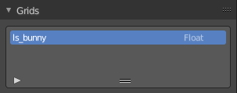

List
OpenVDB can contain multiple grids which represent different “layers” of volume. The List Views shows all the grids in the OpenVDB-file along with its name and data type. It is read only.

Drag Handler
The two vertical lines at the end is a handler with which you can expand the list.

Search Field

You can expand a search field at the bottom of the list. Type in your term and hit enter to filter for your term.

Invert
Exclude the search term instead of searching for it.

Sort by Name
Sort the List by name.

OpenVDB File panel

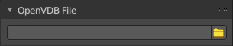
File Path
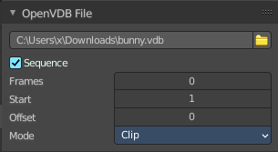
The file path to the vdb file.

Load File
Load an vdb file.

Sequence
Load the OpenVDB-file as an animation loading separate files for individual frames. Ticking this checkbox reveals further functionality.

Frames
Number of frames of the sequence to use.

Start
Global starting frame of the sequence, assuming the first frame has a 1 in the file name.

Offset
Offset the number of the frame to use in the animation.

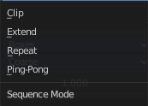
Sequence Mode
Animation setting of the volume sequence before the start frame and after the end frame.

Clip
Hides frames outside the specified frame range.

Extend
Repeats the start frame before, and the end frame after the frame range.

Repeat
Cycles the frames in the sequence; restarting at frame one.

Ping-Pong
Repeats the frames, reversing the playback direction on every other cycle.

Viewport Display panel
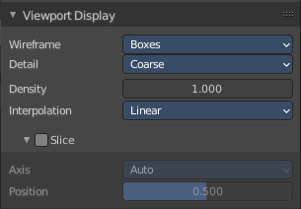

Wireframe
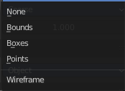
Method used to represent volumes in wire frame shading mode. For heavy volume data sets, it can be useful to set the object to always display as wire frame. This way the 3D Viewport remains responsive but the volume still appears in the final render.

None
The volume is not displayed in wire frame mode.

Bounds
Displays the volume as bounding box for the entire volume grid.

Boxes
Displays a bounding boxes for nodes in the volume tree.

Points
Displays points for nodes in the volume tree.

Detail
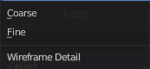
The amount of detail to display for Boxes or Points wire frame mode.

Course
Display one box or point for each intermediate tree node.

Fine
Display a box or point for each leaf node containing 8×8 voxels.

Density
Thickness of the volume in the 3D Viewport. The density of the volume in the render is adjusted via Volume Shading.

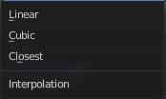
Interpolation
The interpolation method to use for the volumes in solid mode.

Slice subpanel
Slice the domain object along a single axis.

Axis
Auto slices the domain object along the view direction. X Y and Z along the world axis.

Position
The position of the slice.

Render panel

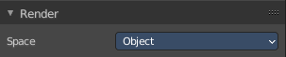

Space
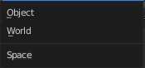
Specifies how volume density and step size are computed relative either to the object or world.

Object
Keeps volume Density and Detail the same regardless of object scale.

World
Specify Step Size and Density in world space.

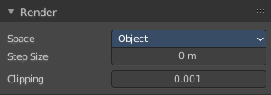
Step Size
Cycles Only
Distance between volume samples. Lower values render more detail at the cost of performance. If set to zero, the step size is automatically determined based on voxel size.

Clipping
Cycles Only
Value under which voxels are considered empty space to optimize rendering.

